Psychological approaches to wellbeing and self-care

# Cognitive Behavioural Therapy

The NHS produced a workbook to help people work through and understand their depression themselves.

It follows the Cognitive Behavioural Therapy approach, and encourages readers to complete the following activities:

* Think of an instance where they were struggling with negative thoughts and fill in the Thought, feeling, emotion cycle of the Cognitive triangle. 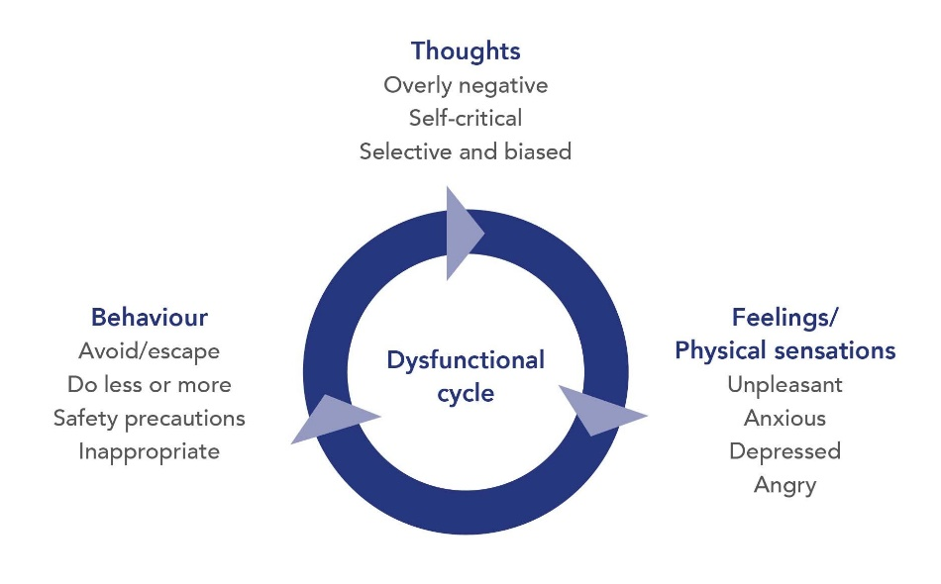
* Taking time to think of activities they enjoy, and then fill out a three day planner with some of these activities to set themselves up to feel better. They suggest:  
  *• one or two things that you used to enjoy  
  • something with other people – maybe an activity with friends  
  • exercise – something you’ve enjoyed in the past, like an exercise class  
  • things you have to do – like looking after yourself, making meals, and  
  medical appointments  
  • a regular time to get up and go to bed – a regular sleeping pattern will  
  make you feel better*
* Challenging unhelpful thoughts – identifying, rephrasing

CBT is a widely established approach to treating mental illness, and studies have shown that CBT alone is 50-75% effective for overcoming depression and anxiety after 5 – 15 modules. (Hedman, et al., 2013)

# Nature-assisted therapy

A more recent development in the field of psychology is the concept of ecopsychology and nature assisted therapies. The phrase ecopsychology was only coined by Theodore Roszak in 1992, but since then it has grown in popularity and now recommended by Mind UK as a supplementary therapy for mental wellbeing.

Some of the activities recommended in self-help ecotherapy include:

* Taking notice of nature, which can include:
  + Find things you can see, hear, taste, smell or touch. For example, grass under your feet or the feeling of wind and sunlight. – this is reminiscent of mindfulness techniques practiced to manage panic attacks.
  + Keep a record of what you notice. Take photos or make notes in a diary or on your phone.
* Bringing nature inside
  + Recordings of wildlife to calm down your space
  + Collecting found items
  + Planting inside
  + Let creative hobbies be inspired by nature
* Do activities outdoors
  + Go for a walk in a green space
  + Do your usual activites outside – eating, creating, etc
  + Watch the stars